Teaching The Violin And The Viola In The Education Of Music Teachers In Turkey
Asist. Prof. Esra DALKIRAN - Assist. Prof. Zeki NACAKCI
Mehmet Akif Ersoy University
Abstract
The worldwide teaching of the violin and the viola is being performed parallel to their recognition from the beginning to the present with the help of universally appreciated works and etudes. However, even if this education originates from the literary archives of the viola and the violin, there happen to be differences and similarities among them. Starting from this point, the study in subject, comprises information about the content and application of “the individual instrument” (the violin and the viola) course in the Turkish curriculum of music teachers.
Key words: Violin education, Viola education, Turkish folk melodies, Violin/Viola Education In Turkey

In Turkey, State Conservatories, Music Departments of the Faculties of Education and Faculties of Fine Arts are the main institutions where training in music is professionally performed.
Among these institutions only graduates of the departments of music of faculties of education become qualified teachers of music who take pedagogical formation courses next to their compulsory courses. There are graduate and post-graduate programmes in these departments.
The course “Training with an individual instrument” is taken 1 lesson per week for 8 terms. This course mainly comprises teaching methods under the name of “Individual Instrument and its Education “in the 8th term after being taught for 7 terms.The credit of the course is 1 for each term.
“The course gradually comprises technical practise and etudes, samples of works of Turkish and other international composers, books and articles about the instrument in cohesion to individual practice and teaching and learning methods in teaching music at schools.”
“Every nation in the world has its own folk music. Numerous countries protect their national music which is an outcome of their cultural heritage and make use of it in several ways. This results generally in the education of music and specifically in the teaching of musical instruments as much as required. Therefore, in the teaching of musical instruments in Turkey, various methods and albums comprising our traditional music are used besides universal teaching methods.”
“It can be seen that other countries have similar applications in teaching music. For instance, “Among British school books are titles such as Folk songs, songs of the British Islands, Songs of Britain, National songs, Folk and National songs. German book titles are Volsweise, Alte Weise, Alte Volkweise, Volkslied. French books that can be listed as examples are Chanson populaire, Melodie populaire, Air Ancien, Vielle melodie, vielle chanson Francaise. Czechoslavakian music books have Czech, Mora and Slovak folk songs. In Balkan school books Narodna melodies are presented next to folk melodies with 5,7,and 9 strokes.”
Expected Outcomes Of The Education Of Individual Instruments
Outcomes are values which are results of planned and organized behavioural means that emerge as expected interests, knowledge, skills and tendencies in students. Below are the expected outcomes of the Individual Music Instrument Education course in departments of teaching music. They have been presented in regard to the level of development starting from the first term and lasting to the 8th in a span of 4 years.
Individual Musical Instrument (Violin-Viola) Education I
- Performs the basic behaviours to play an instrument.
- Uses the fiddlestick promptly and symmetrically.
- Plays the notes in all strings in the first position correctly.
- Recognizes and uses the Legato and Detach techniques.
- Performs single part and simple works.
Individual Musical Instrument (Violin-Viola) Education II
- Remains in the same string by studying shifts of the fingers.
- Recognizes and uses the Legato and Detach techniques.
- Does scale studies comprising four strings.
- Makes double sound studies.
- Performs small scale national and universal works to apply the acquired basic knowledge and skills
Individual Musical Instrument (Violin-Viola) Education III
- Left plays shifting fingers and fastening exercises while right hand plays complex etudes and works comprising the fiddlestick
- Improves to a new posture and plays real permanent exercises.
- Acquires the Staccato technique and makes mixed studies with the learned techniques.
- Acquires and applies the techniques for
- Recognizes and plays known little works (sonata, concertino, etc.) in his field.
- Understands basic procedures of making Vibratos.
Individual Musical Instrument (Violin-Viola) Education IV
- Improves his skills in playing stable and interchanging in two positions.
- Learns Martello and Staccato fiddlestick positions and practises to improve them.
- Makes scale practices in two positions both stable and changing.
- Acquires skills like flajole and pizzicato with techniques such as hand stokes, Mordant, trill,
- Performs traditional melodies and universal work with the learnt techniques.
Individual Musical Instrument (Violin-Viola) Education V
- Learns a new position and makes stable and changing practice with it.
- Makes scale studies comprising three positions.
- Improves his Vibrato.
- Applies enchanted ways of playing.
- Performs traditional melodies and universal work comprising the learnt techniques.
Individual Musical Instrument (Violin-Viola) Education VI
- Learns playing with the fourth position and practises playing with it and the previously learnt positions both stably and interchanging.
- Improves fiddlestick techniques such as Detach, Legato, Martello and Staccato with etudes and scales suiting his level.
- Makes scale studies comprising the four positions.
- Understands and performs the Spiccato technique.
- Performs techniques such Pizzicato and Flajole.
- Plays double sounds and octave sounds.
- Performs traditional melodies and universal work.
Individual Musical Instrument (Violin-Viola) Education VII
- Learns the fifth position and practises playing with it and the previously learnt positions both stably and interchanging.
- Improves learnt fiddlestick techniques by playing scales and etudes suiting his level.
- Applies right arm movements by understanding changes of chords.
- Performs traditional melodies and universal work comprising techniques he has already learnt.

Individual Musical Instrument (Violin-Viola) Education VIII
- Learns and applies “techniques of teaching playing a musical instrument”.
- Makes an repertoire of school songs, national and universal melodies comprising previously learnt positions.
- Performs traditional melodies and universal work.
Evaluation Criteria
Achieving and evaluating the set outcomes does not only require the consideration the different abilities and experiences (individual differences) of the students but also the behavioural measures in the table below.
Evaluation Criteria |  | Measured Skills
Liability to the Programme |  | Being able to fulfil the requirements of the class the student is attending
Exam Performance | Technicality | - Displaying a proper posture; holding the instrument and the fiddlestick appropriately.  - Being able to use the fiddlestick symmetrically.  - Being able to apply the techniques in the etude and work appropriately and effectively (Detach, Legato,Martele,Staccato,Spiccato)  - Being able to perform the sounds in the etude and the work appropriately  - Being able to move among positions appropriately while playing the etude or work and be able to stay sound in the new tone.  - Being able to perform the etude and work appropriately both rhythmically and metrically.  - Being able to perform the etude and work appropriately according to its means of articulation.
Exam Performance | Musicality | - Being able to perform the etude and work as a whole.  - Being able to perform the etude and work in an effective sound.  - Being able to remain in an appropriate scale according to the etude and work.  - Being able to perform according to the style of the period of the etude and work.  - Being able to perform the etude and the work in its appropriate speed.  - Being able to apply the nuances in the etude and work appropriately  - Being able to fulfil the Vibrato effectively.
The state in the mid term |  | Showing the necessary interest to the course throughout the term and act responsible by studying punctually and perform appropriately.

Using Traditional Folk Melodies In The Training Of The Violin And The Viola
First of all to achieve the outcomes stated above universal repertoires and methods are being used in the teaching of the violin and the viola in our country.
When we consider the students who are affected by popular music and the musical background of our country, the likes and interests students have for their own melodies appear to be stronger which is of course quite natural. Therefore, our traditional melodies are used in teaching the violin and the viola. However, during this process of teaching it is directly in the domain of the tutor to use samples of Turkish music and etudes.
Meeting the general purpose of the teaching of musical instruments, using traditional melodies in teaching is thought to have positive supports to permit the student to create a spiritual connection between themselves and their instrument, understand the rhythmic and melody based structure of folk music, improve their abilities of performance and style, improve their memories and their skills in deciphering and transposing.

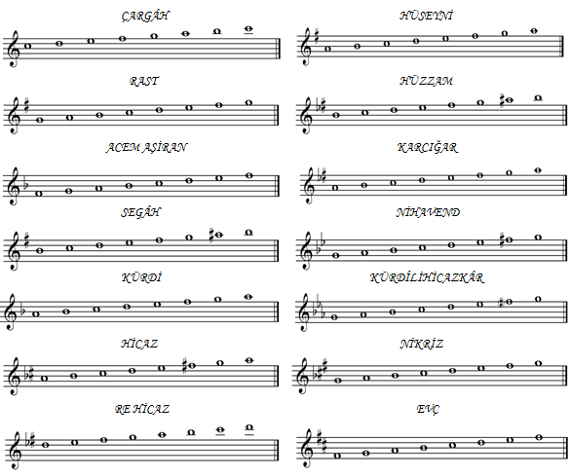
Below you can see scales of Turkish folk music adapted on the Tampere system which is used in teaching the playing of a musical instrument.

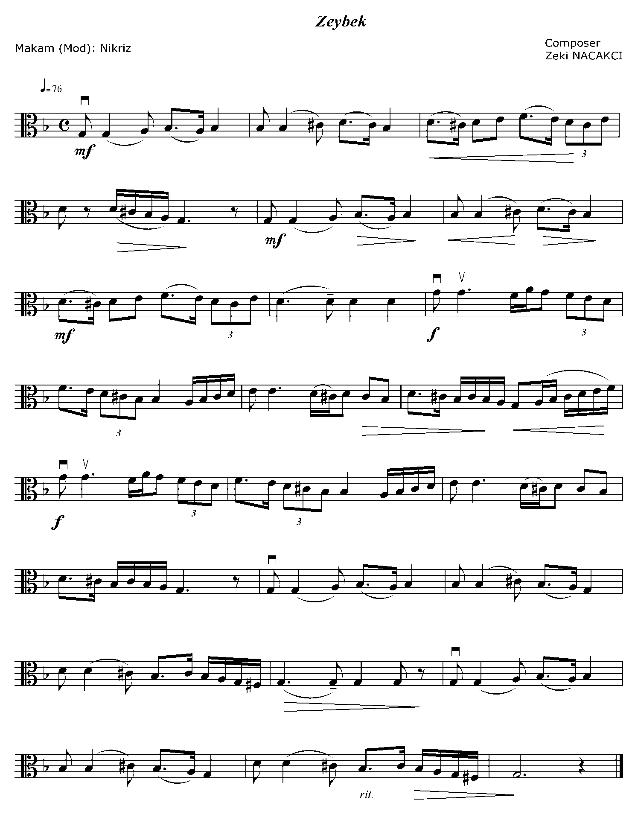
Below are samples of traditional melodies which are used in the teaching of the viola and the violin.

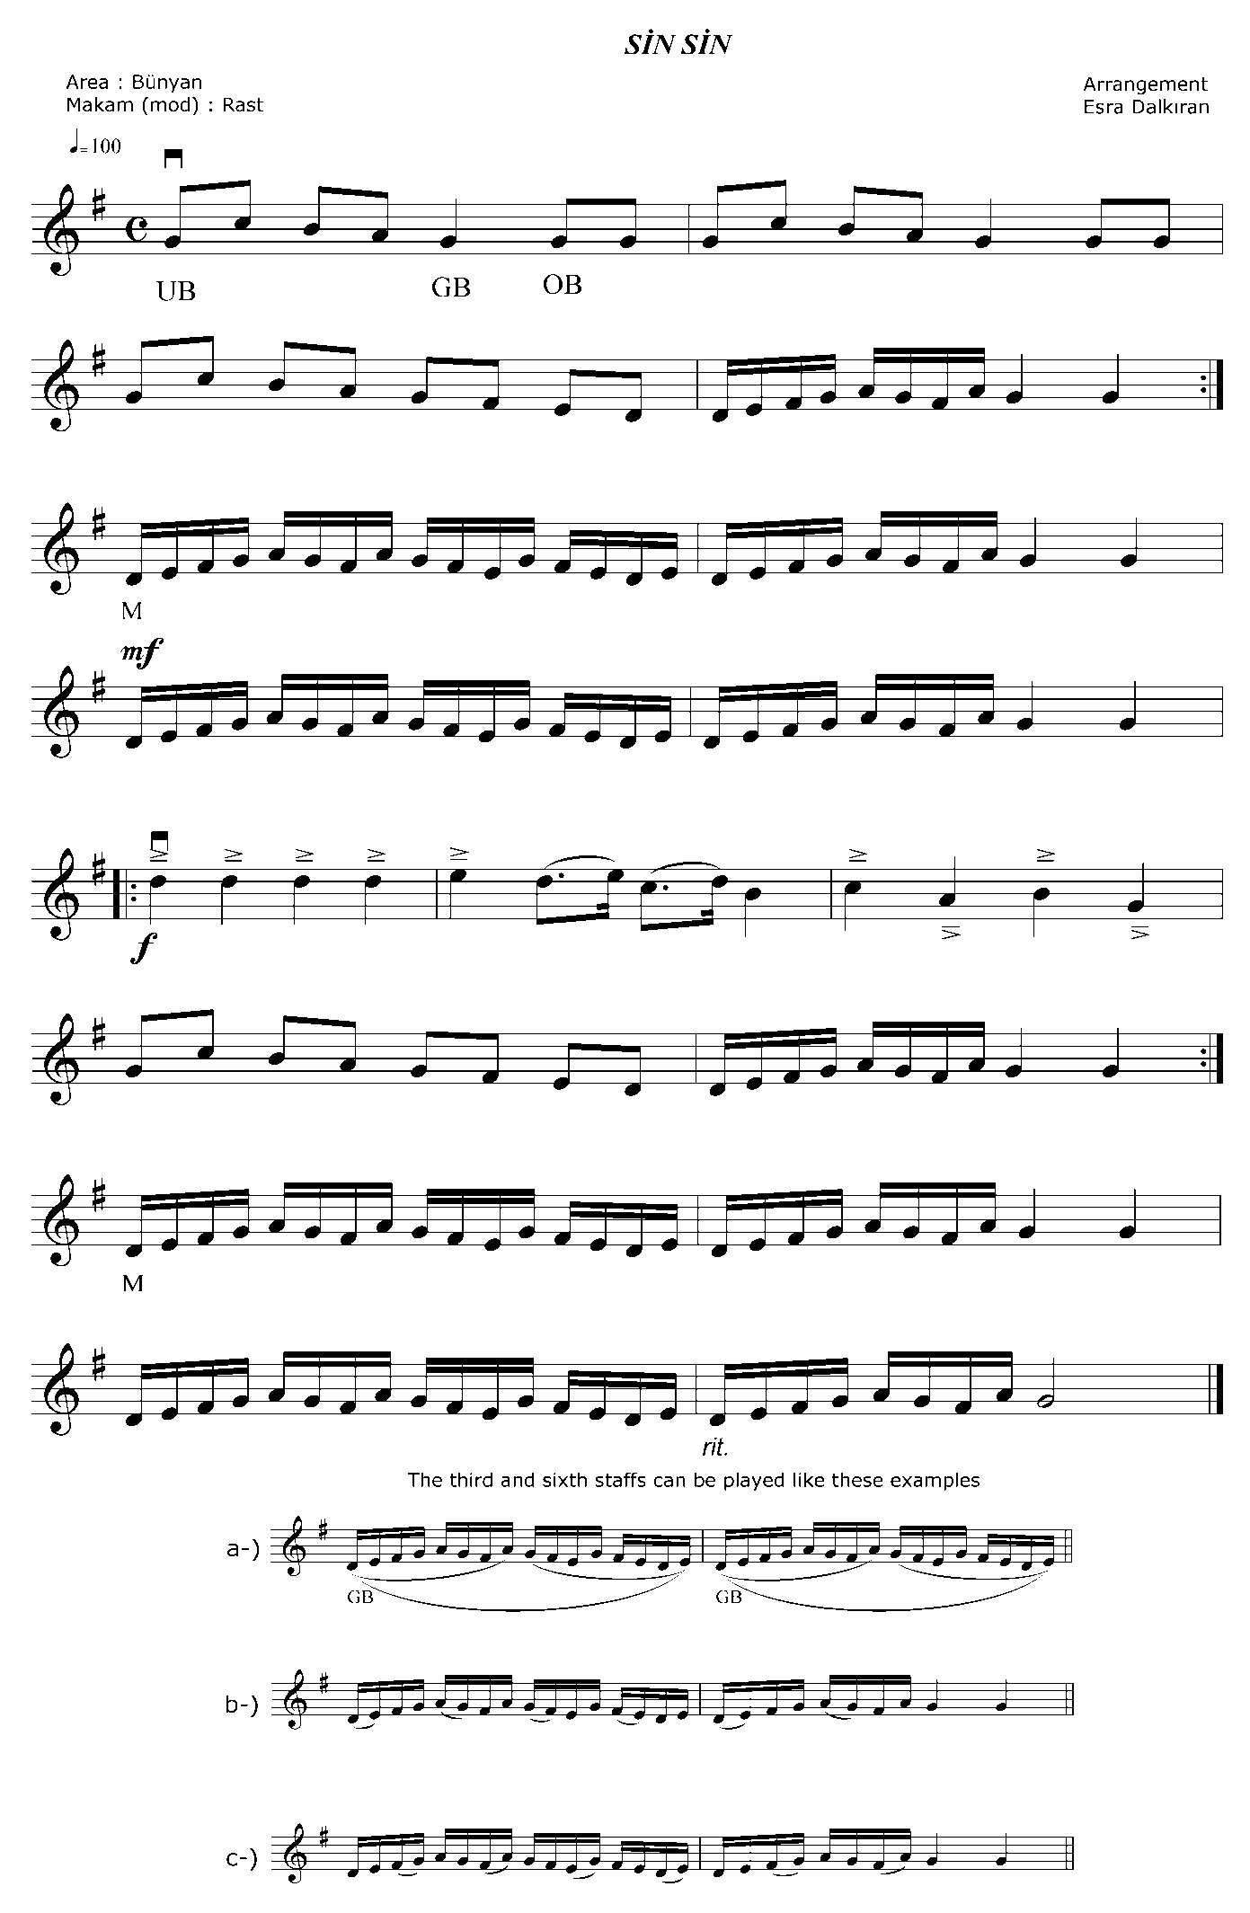

REFERENCES
- DALKIRAN, E.,(2006). Keman Eğitiminde Performansın Ölçülmesi, Yayımlanmamış Doktora Tezi, Gazi Üniversitesi Eğitim Bilimleri Enstitüsü, Ankara.
- NACAKCI, Z.,(2005). Türk Halk Ezgilerine Dayalı Eserlerin Viyola Eğitiminde Kullanılmasının Gerekliliği, Geleneksel Müziklerimiz İçinde Müzik Eğitimi Sempozyumu, Van.
- Yönetken, H.B., (1996). Aktaran: Say, A. Müzik Öğretimi. Ankara.
- Yüksek Öğretim Kurulu,(2006). Müzik Öğretmenliği Eğitim – Öğretim Programı

Assistant Professor Esra DALKIRAN - Assistant Professor Zeki NACAKCI
Mehmet Akif Ersoy University
Fine Arts Teaching Department
Music Teacher Education Program
edalkiran@mehmetakif.edu.tr
znacakci@gmail.com

YÖK,(2006) Müzik Öğretmenliği Eğitim – Öğretim Programı
Nacakcı, Z., (2005).Türk Halk Ezgilerine Dayalı Eserlerin Viyola Eğitiminde Kullanılmasının Gerekliliği.
Yönetken, H.B., Aktaran, SAY, A.(1996). Müzik Öğretimi, p.36
Dalkıran, E., (2006). Keman Eğitiminde Performansın Ölçülmesi

