A SAMPLE OF” STUDY ANALYSIS MODEL” FOR VIOLIN TRAINING: MAZAS, OPUS 36/6

Esra DALKIRAN
Mehmet Akif Ersoy Üniversitesi

Türev BERKİ
Hacettepe Üniversitesi

Abstract

In this study, an original analytic model related to violin education has been made on the Etude in G Majör, Op. 36/6 by Jacques- Féréol Mazas.

Key Words: Violin, etude, analysis, Mazas, difficulty, tecnical exercises.

INTRODUCTION
The etude notion, which can be defined as a special composition created for the performer’s technical progress in his/her playing musical instrument, is an inevitable elements of violin training and repertoire as in every musical instrument. Either study etude or concert etude, each etude plays an important role in helping the student/performer to overcome many difficulties s/he may come up with in the opus in his/her repertoire. Thus, it is clear that it will be helpful to study each etude with its content subject, technical difficulties and methods to overcome these difficulties with an analytical approach.
At this point, it is planned to make a series of studies, developing an original etude analysis method to be practiced in various etudes chosen from violin literature. For the first outcome of these studies, the opus of a renowned 19th century composer, virtuoso and pedagogue in violin literature, Jacques- Féréol Mazas’s opus 36/6 numbered sol-mode etude. The analysis to be made in his etude is based on two dimensions “technical difficulties and their technical solutions”.

ANALYSIS

The etude was formed to practice the Détaché technique, worked through arpeggios, split trios and I-III-V position transitions in left hand, in the same quality in each three part of the bow.

Technical Difficulties

The difficulties can be described in two categories. One of them is the use of the bow, the other is the use of left hand.

Table1. Findings related to the difficulties of the string use
Difficulty | Scale Nr. used in the etude | Frequency of use in the etude (%)
Détaché | 1-8, 13-47 | %82
Ability to classify the bow properly | All scales | %100
Bow syncope | 9,10,11,12,32,33,34,35 | %17

Table2. Findings related to the difficulties of the left hand use
Difficulty | Scale Nr. used in the etude | Frequency of use in the etude (%)
Split trios | 1,2,3,4,5,6,7,9,10,11,12,13,14,15,  17,18,26,27,28,29,30,31,32,33,34,35,  43,44,45,46 | %63
Arpeggio | 8,16,18,20,21,22,23,24,25 | %19
I-III Transition of position | 4,5,12,13,14,15,16,17,18,19,20,21,22,  27,34,36,37,38,40 | %40
III-V Transition of position | 35 | %0,2
The use of 4th finger as the 5th finger | 18,35 | %0,4
The use of Flageolet sound | 36,38 | %0,4

Technical Studies to Solve Difficulties

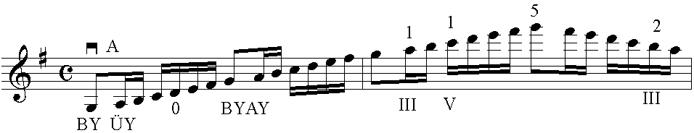
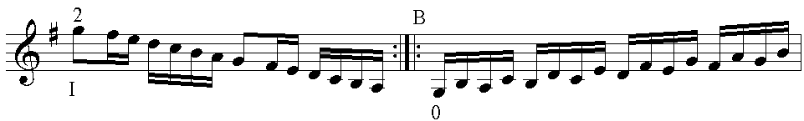

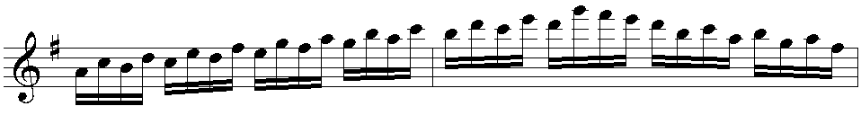

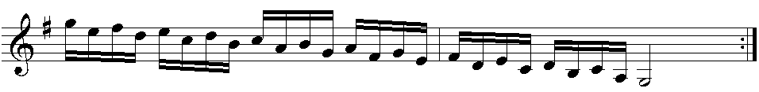
1. Note Preparation study, nr.1

With this study spread into three octaves in order to make preparations for I-III-V transition of positions in the etude, it will be possible to classify the bow properly and practice the Détaché technique, which is used in the most of the opus, in each three part of the bow (AY, ÜY, O).

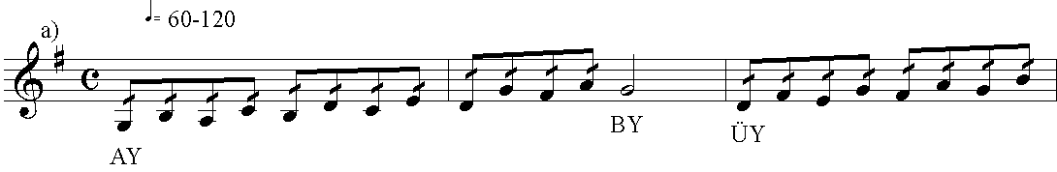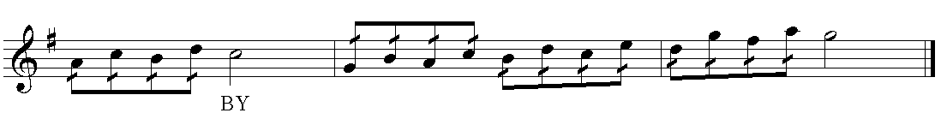

b)
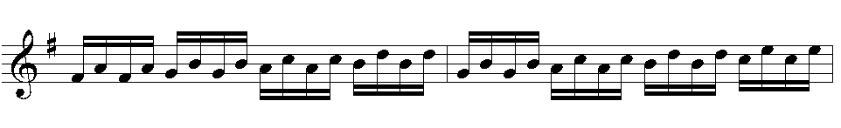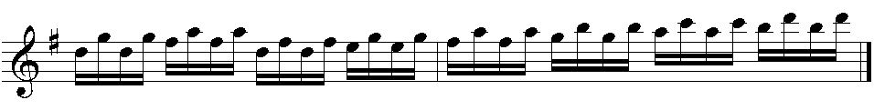

2. Note Preparation study, nr.2

This study, which is thought to make Détaché technique more effective and to accelerate the etude systematically , can be practiced in 2-7, 17, 19, 26, 27 and 43-46 scales of the etude.
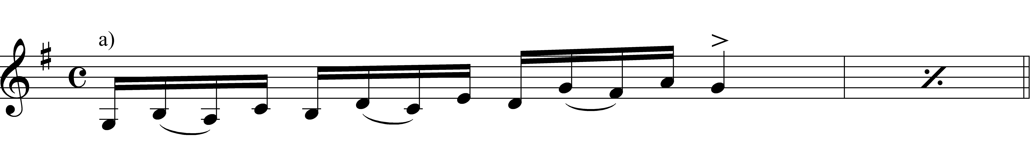
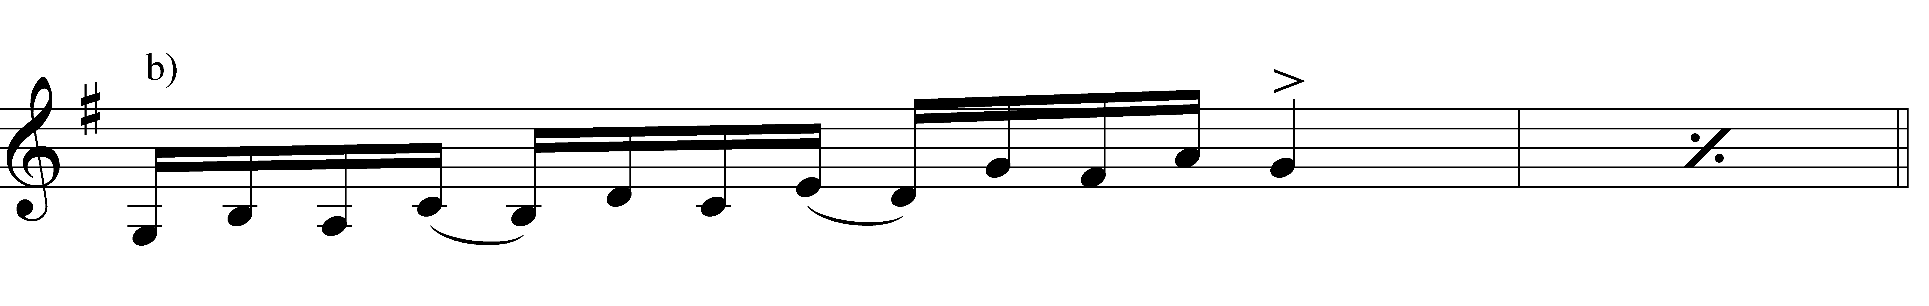
3. Note Technical study, scale nr. 9-12 (For the bow syncope)

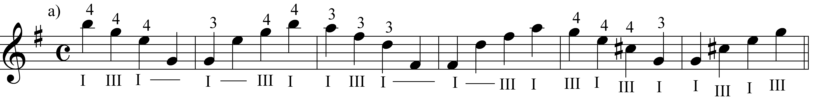

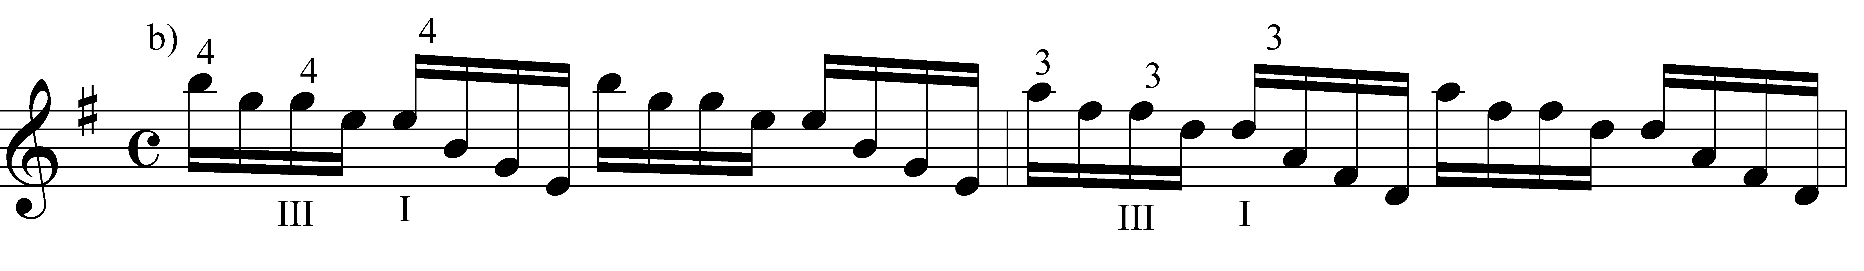
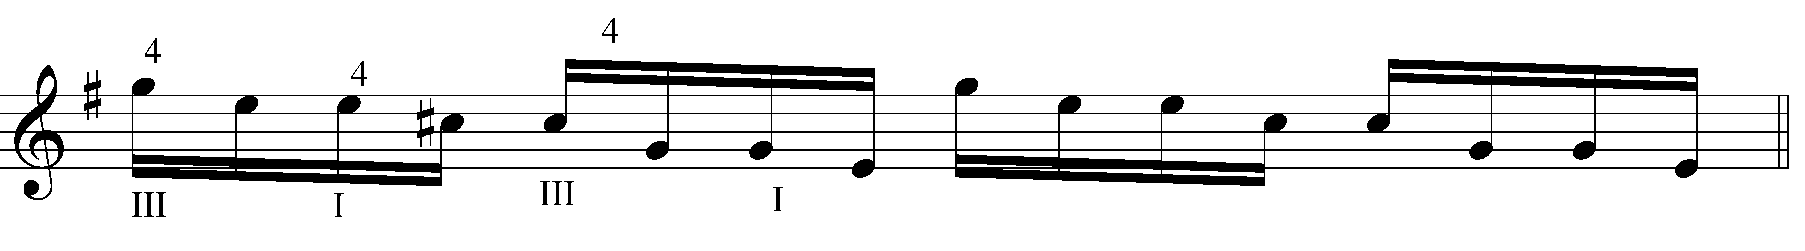
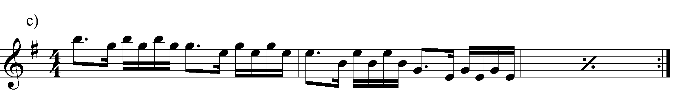

4. Note Technical study, scale nr. 13-15 (for I-III transition of positions)

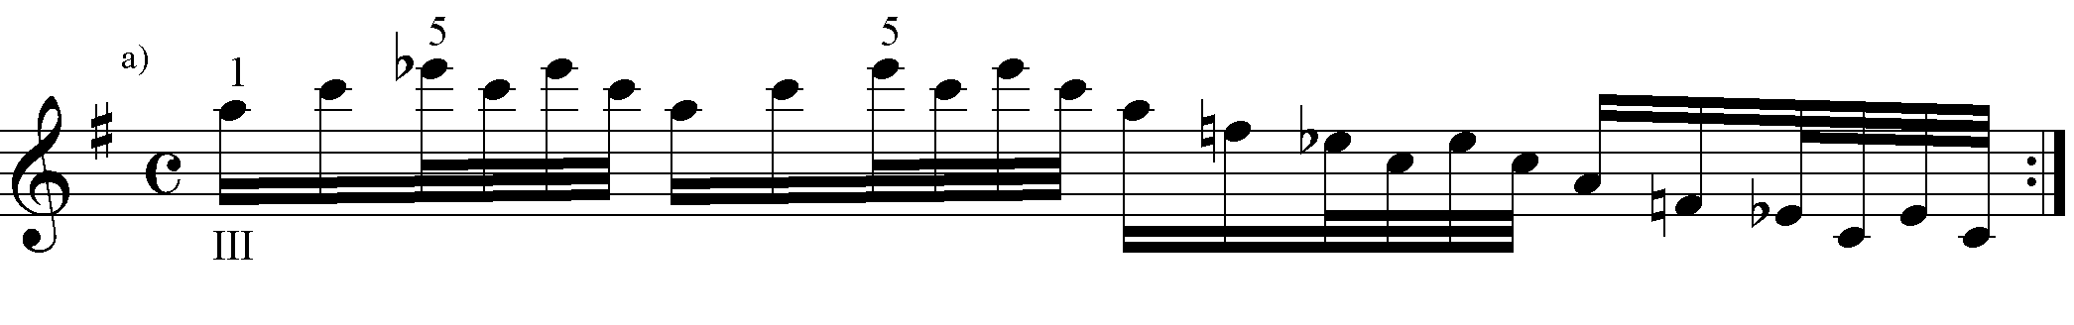
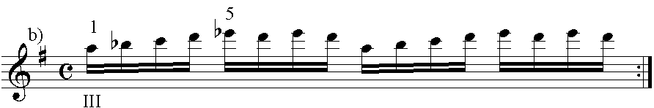

5. Note Technical study, scale nr. 18

The distinctive feature of this study is the use of the 4th finger as the 5th finger without changing position.

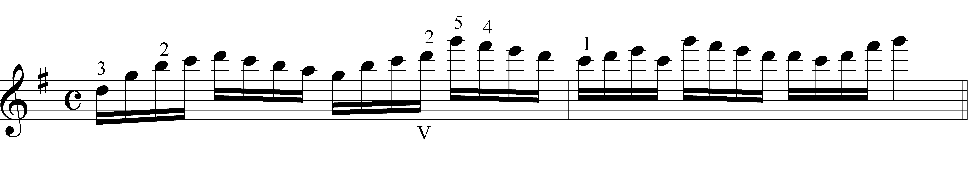
6. Note Technical study, scale nr. 35 (For III-V transition of positions)

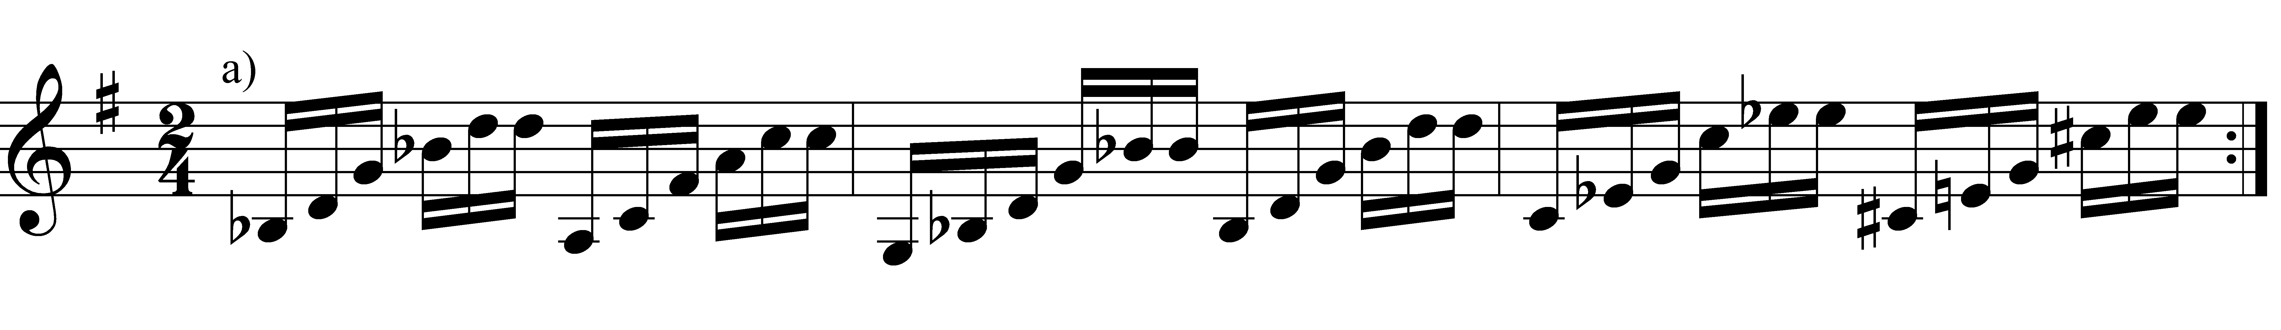

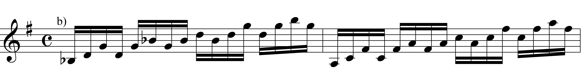

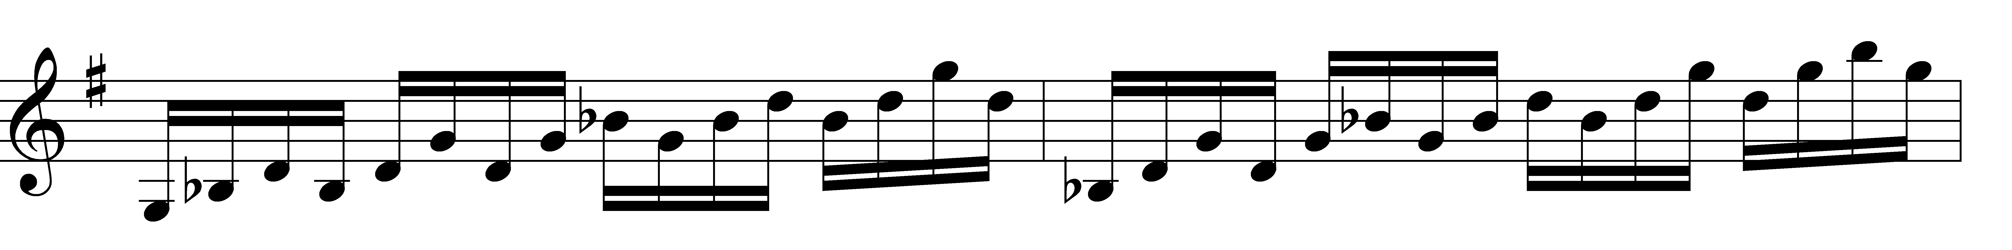

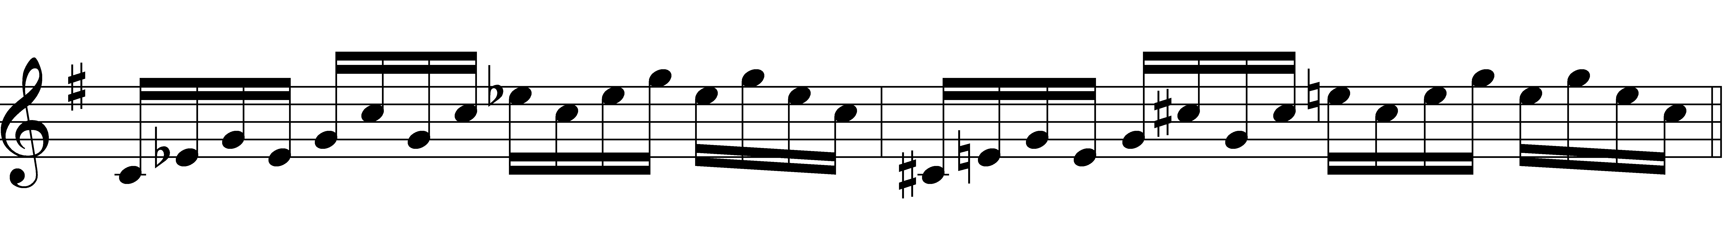
7. Note Technical study, scale nr. 21-23

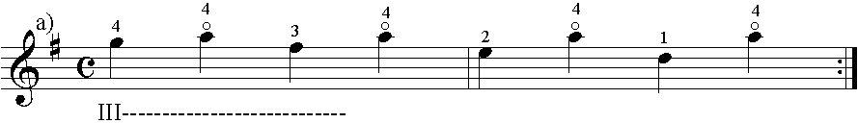

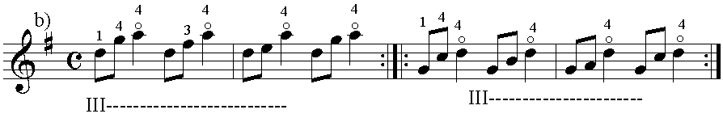

8. Note Technical study, scale nr. 36-38

This can be practiced in the other strings.

RESULT AND SUGGESTIONS

In the result of the analysis made on Maza’s number 6 violin etude, three difficulties related to the bow use and six difficulties related to the left hand use were detected and 15 technical studies were described to make preparations for the etude and to sort out those difficulties. For each difficulty detected, there is at least one study.

Tablo 3. Difficulty-Technical study relation

Difficulty | Technical study
Détaché | 1, 2a, 2b, 7a, 7b
Proper classification of the bow | 1, 2a
Bow syncope | 3a, 3b
Split trios | 1, 2a, 2b, 3a, 3b, 4c, 5a
Arpeggio | 7a, 7b
I-III transition of positions | 4a, 4b, 4c
III-V transition of positions | 6
The use of 5th finger as the 4th singer | 5a, 5b, 6
The use of Flageolet sound | 8a, 8b

It is evident that the studies described in an opus to sort out the technical difficulties differ from person to person and each performer/player has a different approach to the technical texture of the opus. The basic study in this approach in this study is that whatever the level of the performer/player and the opus be, it seems possible to sort out all difficulties describing appropriate technical studies and creativity notion (Berki,1994).
The process of “difficulty detection and technical study formation” is only one of the stages from the moment of reception of each etude for the repertoire to the moment of concert or examination performance.

From this point on, “the stages of analysis and vocalization studies”, which is among the stages of our study, are presented below as a suggestion. It will be possible to enjoy the vocalization of the opus whereby a perfect study in which each stage is perfectly practiced.

- Deciphering the etude roughly
- Listening to the etude from different sources
- Detecting all technical difficulties in the etude
- Studying all the data related to the use of duate and bow and making the necessary changes
- Making different technical studies for each difficulty
- Through technical studies,
a) Sorting out difficulties,
b) Sorting out the bindings between consecutive difficulties,
c) Combining all difficulties,
- Studying the nuance, tempo and version elements, practicing them and making necessary changes,
- Creating a concert-like atmosphere in the etude and vocalizing it in concentration over and over,
- Making and realizing necessary changes to perform the original version.

REFERENCES

Sadie, S., The New Grove Dictionary of Music and Musicians, Volume 6, Macmillan Publishers Limited, 291, London, 1995.
Sadie, S., The New Grove Dictionary of Music and Musicians, Volume 11, Macmillan Publishers Limited, 863-864, London, 1995.
Scholes, P., The Oxford Companion to Music, Oxford University Pres, 336, Oxford, 1992.
Stowell, R., Violin Technique and Performance Practice in the Late Eigtheenth and Early Nineteenth Centruies, Cambridge University Pres, 7-326, New York, 1990.
Stowell, R., The Cambridge Companion to Violin, Cambridge University Pres, 62, Cambridge, 1992.

Asst.Prof.Dr.Esra DALKIRAN
Eğitim Fakültesi, Güzel Sanatlar Eğitimi Bölümü
edalkiran@mehmetakif.edu.tr

Prof.Dr.Türev BERKİ
Devlet Konservatuarı, Müzikoloji Bölümü
tberki@hacettepe.edu.tr

Sadie, S., The New Grove Dictionary of Music and Musicians, Volume 6, Macmillan Publishers Limited, 291, London, 1995.
Scholes, P., The Oxford Companion to Music, Oxford University Pres, 336, Oxford, 1992.

